Project Design Phase
Problem – Solution Fit Template

Date | 07 March 2026
Team ID
Project Name | Cab booking
Maximum Marks | 2 Marks

Problem – Solution Fit Template:
The Problem–Solution Fit means identifying a real problem faced by users and ensuring that the proposed solution effectively solves that problem. In the context of a cab booking system, many users face difficulties such as finding available cabs quickly, high waiting times, lack of fare transparency, and safety concerns.
This project focuses on providing a smart and efficient cab booking platform that connects passengers with nearby drivers through a simple digital interface. The system allows users to book rides instantly, track the driver in real time, view estimated fares, and make secure online payments.
Purpose:
1. Solve Transportation Problems
Provide users with a quick and reliable way to book cabs without the need to search manually for transportation.
2. Reduce Waiting Time
Use location-based services to connect users with the nearest available drivers.
3. Improve Fare Transparency
Display estimated fares before confirming the ride so that users are aware of the cost.
4. Enhance Safety and Trust
Provide driver details, ride tracking, and ratings to ensure passenger safety and build trust.
5. Improve User Experience
Offer a simple and easy-to-use platform for booking rides, tracking trips, and making payments.
6. Increase Efficiency in Urban Transportation
Optimize driver-passenger matching to reduce idle time for drivers and waiting time for passengers.

Template:
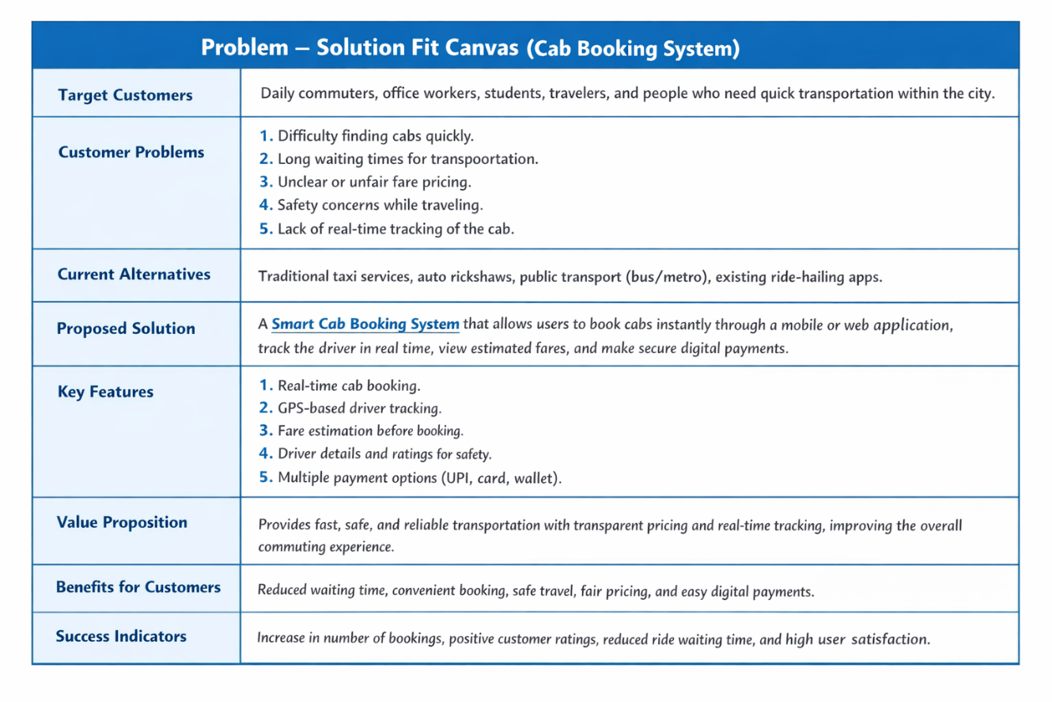
References:
- https://www.ideahackers.network/problem-solution-fit-canvas/
- https://medium.com/@epicantus/problem-solution-fit-canvas-aa3dd59cb4fe

